# Using Real Time Computer Vision for Facial Detection in Automatic Attendance System

##### **Nabin Chand Harshit GargDr. Shynu P G**

MCA MCAAssociate Professor

[**nabin.chand2019@vitstudent.ac.in**](mailto:nabin.chand2019@vitstudent.ac.in)[**harshit.garg2019@vitstudent.ac.in**](mailto:harshit.garg2019@vitstudent.ac.in)[**pgshynu@vit.ac.in**](mailto:pgshynu@vit.ac.in)

”School of Information Technology and Engineering, Vellore Institute of Technology (Vellore) ”

***Abstract*-** Maintaining attendance is an integral part in all the institutes for keeping a check on the performance of the students. All institute has their own method, while some institute use the old paper and pen technique to take attendance manually, others have adopted automatic attendance methods such as biometric attendance. Although there are many automatic methods used for registering attendance for students like biometric attendance it is still time consuming as students have to line up to give their fingerprint on the biometric scanner for attendance. This project describes the efficient algorithm that automatically registers attendance for the students attending the class by taking a photo of them using digital camera which continuously captures images of students and then comparing their faces with the ones stored in the database, if the system recognized any face that are stored in the database, the attendance is given for the recognized faces without needing any manual work to be done by the teacher present in the class. This is done by four stages. Firstly, the images of the student enrolled in the college are clicked and stored in a database for easy accessibility. Secondly, a camera is placed in the front of the class which detects the students attending the class, the output of which is sent to the third stage i.e. face recognition system which checks it with the students in the database and if the student face matches with one in the database attendance is given.

***Index Terms***- Machine Learning, Deep Learning, CNN, Facial Recognition, OpenCV

1. **INTRODUCTION**

Attendance is an integral part to determine the performance of a student in class. This is an important reason the educational institutes to maintain proper attendance for the students. In general, there are two types of attendance keeping system in educational institutes namely, Manual Attendance System (MAS) and Automatic Attendance System (AAS). In Manual Attendance System follow the manual pen and paper process. This takes lot of time which is wasted instead of teaching and if there is a batch of lots of student (more than 60) then it is difficult for the teacher to understand that if the attendance given was a proxy or not. Next was the Automatic Attendance System in which there was biometric attendance. In this there is fingerprint biometric system which include the students registering attendance in a portable finger-print sensor which is passed around the class and this may be intrusive.

Humans generally identify a person by their faces and with the advancement in computing capability of the computers it is possible. In this paper we discuss about how we can use a neural network to detect and recognize faces in the class room and mark the attendance accordingly. Face recognition has characteristics that other automatic attendance management systems do not have as it can be used from a distance and no special action is required for authentication. The two common human face recognition techniques are

1. Feature based approach.
2. Brightness based approach.

The Feature based approach is also known as the local face recognition which is used in pointing the key features in a face like nose, mouth, eyes etc. and the Brightness based approach is termed as global face recognition used in recognizing all parts of the image.

1. **RELATED WORK**

In **[1]** the author developed an automated attendance management system using face recognition that leverages on cloud computing infrastructure called FACECUBE. FACECUBE take images of the class using IP camera placed in the front of a classroom to capture video of the entire class. FACECUBE is a light weight application that runs on the background of the on-premise local server and is responsible for listening to attendance and then sends all acquired images to cloud web server for storage through web service mechanism where they are processed. The face detection is done with Haar features which can be used to detect multiple faces in a picture. The application FACECUBE uses Eigenface algorithm for face recognition.

In this paper **[2]**, the image is captured and then the face in the image is detected using Viola Jones algorithm for face detection which is fast so it can be used for real-time application. Viola-Jones algorithm uses Integral Image and AdaBoost algorithm as its classifier. The image of the faces extracted is pre-processed like resizing, Histogram Normalization. The database creation includes the images of all the students enrolled in the college with different angles and then extracting the haar-like features and then later pre-processing and storing the data in the database. For feature extraction and classification, Principal component analysis (PCA) and Support Vector Machine (SVM) is used respectively.

In this paper **[3]**, the image is captured and the faces in the image are detected using Viola-Jones object detection framework. The detection process has three stages. Firstly, the faces are detected from the image using Haar features then they used a AdaBoost learning algorithm to classify the image. It operates by choosing an algorithm and then iteratively making it efficient. At first equal weights are chosen for the training dataset and at each step of the iterations the weights of the incorrectly classified examples is increased. This is done multiple times and then the weighted sum of the n iterations forms the final mode.

In this paper **[4]**, the video of the incoming students is taken and the face is detected with the help of YOLO (You Only Look Once).The detected faces are separated and stored separately in the system. The detected faces are then taken and put into a Siamese network one by one which uses One-Shot Learning. The result of the recognition face will be stored in a file. Then once the faces are recognized the respective images are deleted from the system so than no extra space is wasted.

In this paper **[5]**,”the video of the students is taken. The face detection is done using HOG (Histogram of Oriented Gradients) and then the detected faces are taken and put through a simple linear Support Vector Machine (SVM). It is a discriminative classifier. The work of the SVM is if we give a dataset with the respective labels then it produces a hyperplane which separates the different classes present. Although the proposed model didn’t produce effective results. ”

In this study **[6]**, attendance system was developed by combining existing RFID technology with facial recognition. An attendance plan is an important part of facilitating data collection. The program to attend meetings is often encountered in the technological age as today the RFID program is in attendance. In the first RFID sensor test in 11 tests, the sensor was able to distinguish all pre-registered cards and non-registered cards. This test is done from 1 cm to 4 cm in length. In addition, in the second facial recognition test, in the 100-face recognition test for different facial disorders, the system was able to recognize faces 93 times and thus the system had a 93% success rate.

In this paper **[7]**, an existing management system is proposed that can detect and identify the entire category face in a few photos and mark the students present. IoT cameras were used instead of the smartphone camera to increase coverage and reduce the number of missing attendees. In addition to the reduction of manual labor, it was also confirmed that the system was completely safe. The proposed system mainly consists of the IoT Camera Module, a custom back-end server and separate Android apps for teachers and students. The system is also able to provide high accuracy at low cost compared to other similar applications which is why it is a real must-have.

**[8]** Artificial Neural networks are used at the launch of this real-time cum monitoring system that can be monitored and set to work. Some of the great features of this new method include the presence of a face using a single blurred mode on the smartphones of the university class, another real-time monitoring of location centers and workplaces that could place this as a first line of defense for those who have access. An easy-to-use graphical user interface provides flexibility and ease in implementing these powerful face recognition algorithms provided with deep learning. We achieved a high accuracy of 74 percent recognition while using a real-time monitoring algorithm. This work was done as a solution to the lack of a powerful and user-friendly face recognition system.

The main purpose of this work [9] is to make the marking system and managers automatically available, convenient and convenient. In this work the facial recognition of the face is done by image printing techniques. The used image is used to match the record already stored and the attendance is marked in the database. The proposed system utilized 4 modules such as image capture, group image segmentation and face detection, face recognition and recognition, reconstruction in the database.”

To”overcome the queuing problem in this article **[10],** the authors discussed the prototype system for managing student attendance in classroom based on deep learning facial recognition technology without queue. Feature extraction uses 128-d facial embeddings from FaceNet, and code implementation uses libraries originating from opencv and dlib. The installation of the device is done in such a way that it allows the process of identifying the faces of students present in the classroom can be done during the learning session in the class is still ongoing. The results show that this system is able to detect the presence of students in the classroom well. ”

This paper **[11],** ”presents development of face recognition for student attendance using Raspberry Pi. Face recognition is a highly efficient and an accurate tool in enhancing security. With nano devices such as Raspberry Pi and Raspberry Pi night vision cameras, lecturers record student attendance to class with face-to-face identification systems. Small night-vision raspberry cameras are installed on the classroom door frame in the classroom to capture video, approved to Raspberry Pi for face detection and recognition. The proposed method is implemented on Raspberry Pi and Raspberry Night vision which is tested on various standard datasets. Experimental results validate the efficiency of the proposed recognition method. ”

The”main objective of this research paper **[12]** is to develop an automatic attendance monitoring system through face detection and recognition. Challenges for face recognition like facial expressions, change in hairstyles, the presence of some object or intensity of light can be tackled. The proposed system is tested on students at college campus and system identifies faces at a very fast rate with accuracy 99.3% using Dlib and face recognition libraries. ”

***DRAWBACKS OF EXISTING MODEL***

*Table 1: Literature survey conclusion*

|  |  |
| --- | --- |
| **Types of System** | **Drawbacks** |
| RFID Based | Fraudulent usage |
| IRIS and Retina Based | Privacy of the user is invaded |
| Wireless Based | Bad topography leads to poor performance |
| Fingerprint Based | Consumes more time as students need to wait to mark their attendance |

1. **PROPOSED WORK**

The complete system is divided into 3 Modules i.e. creation of a database in a systematic order, detecting the faces and training the data and finally recognizing the faces and marking attendance.

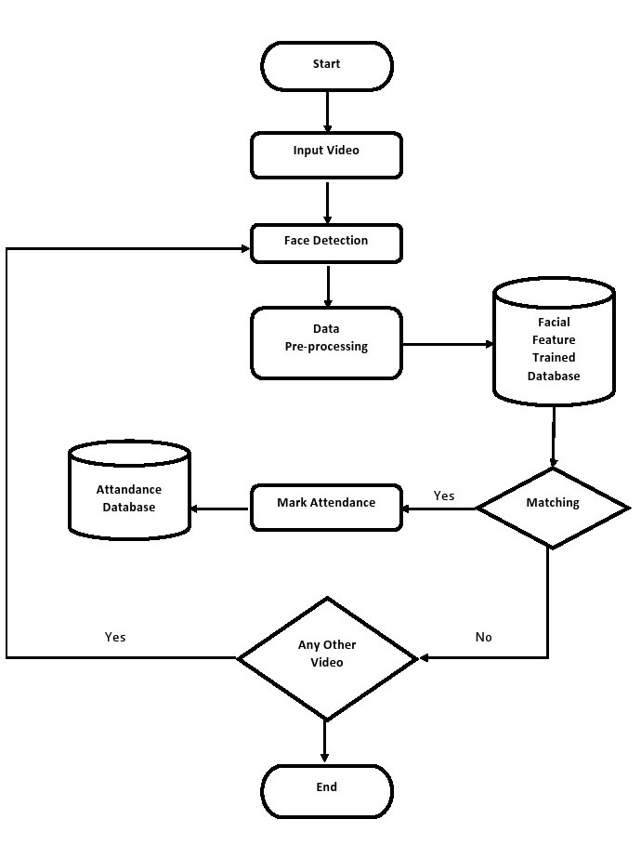

*Figure 1: Flow Chart*

1. ***Database Creation:***

Firstly, we need approximately 20-30 pictures of each student with different expressions so that the model trains in a better way and can classify faces efficiently. In order to create a quality rich database, we have to apply OpenCV functionalities to the data for better detection of faces and thus minimalizing the factor that could lead to an inefficient picture such as the lightening, background of the image, capturing face features properly and so on. ”The images captured from the camera might have brightness issues in it, which should be needed to be removed for suitable outcome. Hence, for enhancement seized images are renewed to grayscale images. Then these pictures are to be stored in different files with their name labels on it. *The more the Data the better the Model.* Also, we can’t throw every data we have towards our algorithm, it needs to be accurate since in data science the quality of data determines the efficiency of the system. ”

## **Face Detection:**

The”Viola-Jones algorithm was implemented for Face detection. This algorithm consists of the cascading of Haar features and Adaboost. All human faces share some similar properties. These similarities are matched in the Viola-Jones algorithm using Haar Features. A Haar-like feature considers adjacent rectangular regions at a specific location in a detection window, sums up the pixel readings in each area, and calculates the difference between these summations of the readings. This difference is then used to categorize the subsections of an image. In the detection phase of the Viola Jones Face detection algorithm, a window of the target size is moved over an input image, and for each subsection of the image, the Haar-like feature is calculated. This difference is then compared to a learned threshold that separates non-faces from faces. Because such a Haar-like feature is only a weak classifier, so a large number of Haar-like features are necessary to describe a face with sufficient accuracy. In the Viola-Jones Face detection, the Haar-like features are therefore organized as a classifier cascade to form a strong classifier. ”

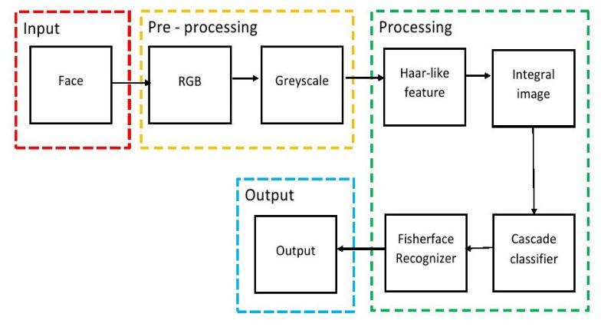

*Figure 2: Methodology*

1. ***Face Recognition:***

Face recognition is done using Fisherfaces face recognizer. This algorithm is an”improved version of the Eigenfaces. Eigenfaces algorithm doesn't focus on the features that discriminate one individual from another. Instead, it concentrates on the ones that represent all the faces of all the people in the training data, as a whole. Whereas FisherFaces face recognizer algorithm extracts principal components that differentiate one person from the others. In that sense, an individual's components do not dominate (become more useful) over the others. ”

1. **CONCLUSION**

The”attendance system is one of the supporting system that

is very necessary in the educational environment at the

university. Most attendance systems today still require time

and intervention of teachers and students, and still having

queue problem. The best of results were obtained

even with the imperfection in the provided input image. Thus,

the system is fairly reliable. ”

1. **FUTURE SCOPE**

The”future work will involve the implementation of a database with the entries of all the students for easy updating of attendance. Also, a Graphical User Interface can be made for ease of access and better appearance. This will include automatic entries into the database and updating the attendance as and when the faces are recognized, making the whole of the system automated. ”

1. **REFERENCES**

[1] Godswill et al. "Automated Student Attendance Management System Using Face Recognition.", International Journal of Educational Research and Information Science. Vol. 5, No. 4, 2018, pp. 31-37.

[2] Shireesha Chintalapati et al. "Automated Attendance Management System Based On Face Recognition Algorithms.",2013 IEEE International Conference on Computational Intelligence and Computing Reasearch.

[3] Pooja G.R, Poornima M et al. "Automated Attendance System using Image Processing.", International Journal of Advanced Networking & Applications(IJANA), pp. 363-367.

[4] Aditya Ladage et al. “E-attendance system using face recognition.”, International Journal of Advance Research, Ideas and Innovations in Technology, pp. 1439-1442.

[5] Anushka Waingankar et al. “Face Recognition based Attendance Management System using Machine Learning.”, International Research Journal of Engineering and Technology (IRJET), pp. 1979-1985

[6] Basthomi, Faisal Rohman, et al. "Implementation of RFID Attendance System with Face Detection using Validation Viola-Jones and Local Binary Pattern Histogram Method." 2019 International Symposium on Electronics and Smart Devices (ISESD). IEEE, 2019.

[7] Dmello, Royston, et al. "Automated Facial Recognition Attendance System Leveraging IoT Cameras." 2019 9th International Conference on Cloud Computing, Data Science & Engineering (Confluence). IEEE, 2019.

[8] Harikrishnan, J., et al. "Vision-Face Recognition Attendance Monitoring System for Surveillance using Deep Learning Technology and Computer Vision." 2019 International Conference on Vision Towards Emerging Trends in Communication and Networking (ViTECoN). IEEE, 2019.

[9] WS, Jenif D. Souza, S. Jothi, and A. Chandrasekar. "Automated Attendance Marking and Management System by Facial Recognition Using Histogram." 2019 5th International Conference on Advanced Computing & Communication Systems (ICACCS). IEEE, 2019.

[10] Handaga, Bana, Budi Murtiyasa, and Jan Wantoro. "Attendance System based on Deep Learning Face Recognition without Queue." 2019 Fourth International Conference on Informatics and Computing (ICIC). IEEE, 2019.

[11] Hasban, A. S., et al. "Face recognition for Student Attendance using Raspberry Pi." 2019 IEEE Asia-Pacific Conference on Applied Electromagnetics (APACE). IEEE, 2019.

[12] Joseph Redmon et al.“You Only Look Once: Unified, Real-Time Object Detection.”, arXiv:1506.02640v5 [cs.CV] 9 May 2016.

[13] Gregory Koch et al. “Siamese Neural Networks for One-shot Image Recognition”, Proceedings of the 32nd International Conference on Machine Learning, Lille, France, 2015. JMLR: W&CP volume 37.